

Yale School of Management

Emma Seppälä, Ph.D.

Positively Energizing Leadership



Reflection

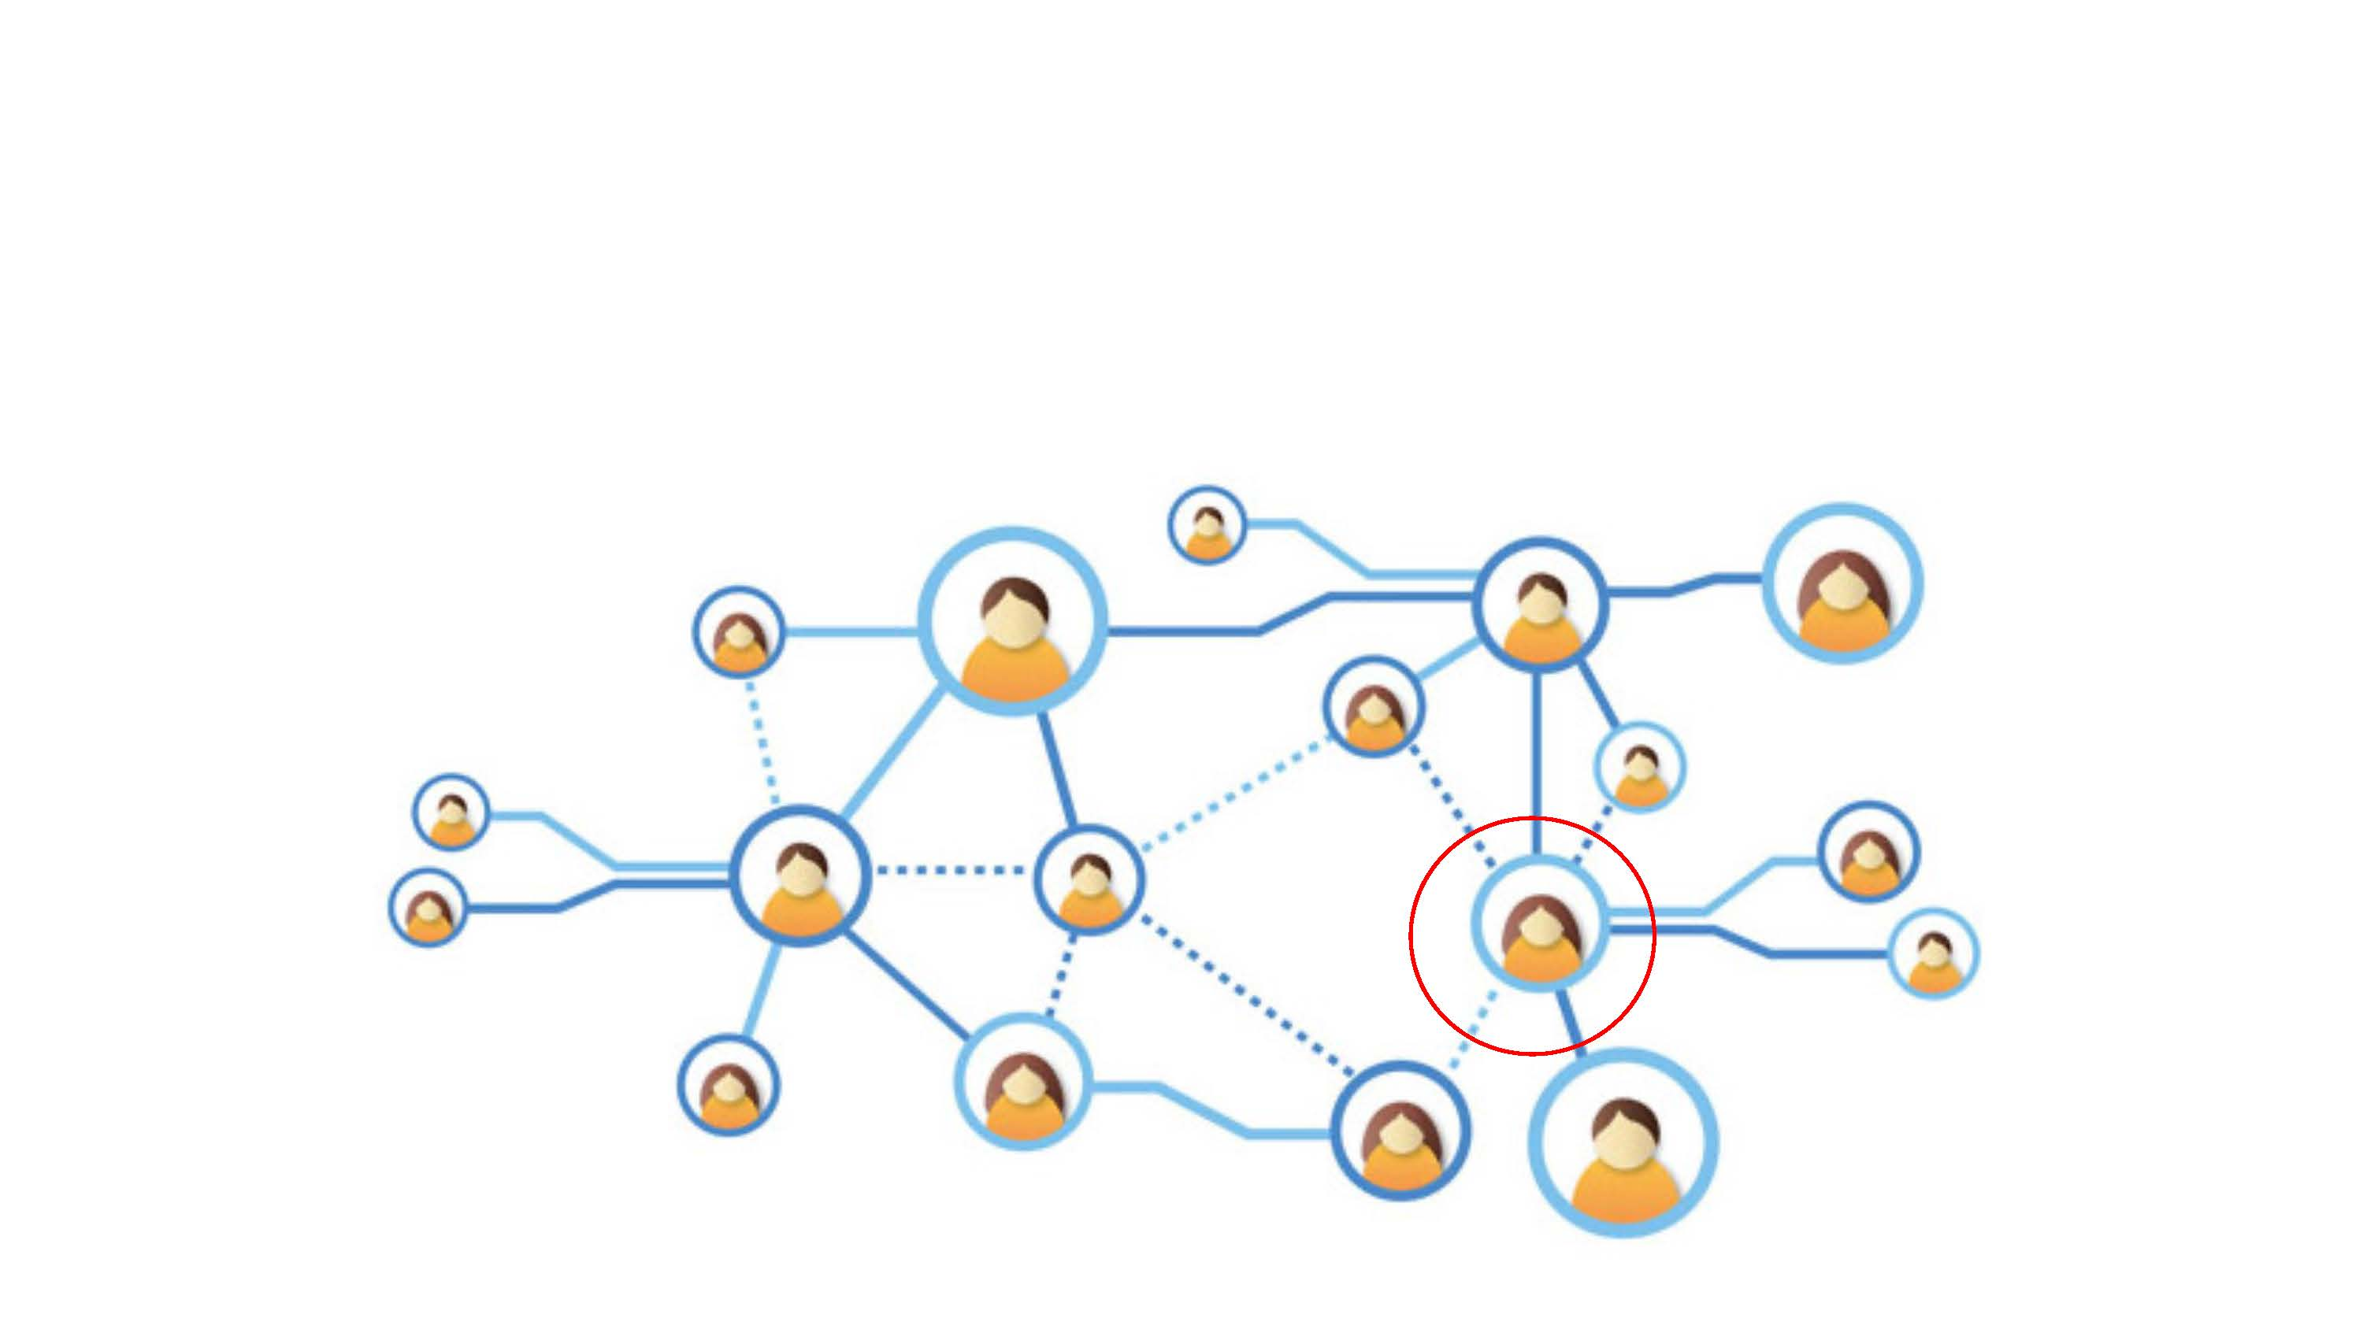

Typically, when you interact with this person, how does it impact your energy level?

Positive Energizer Network

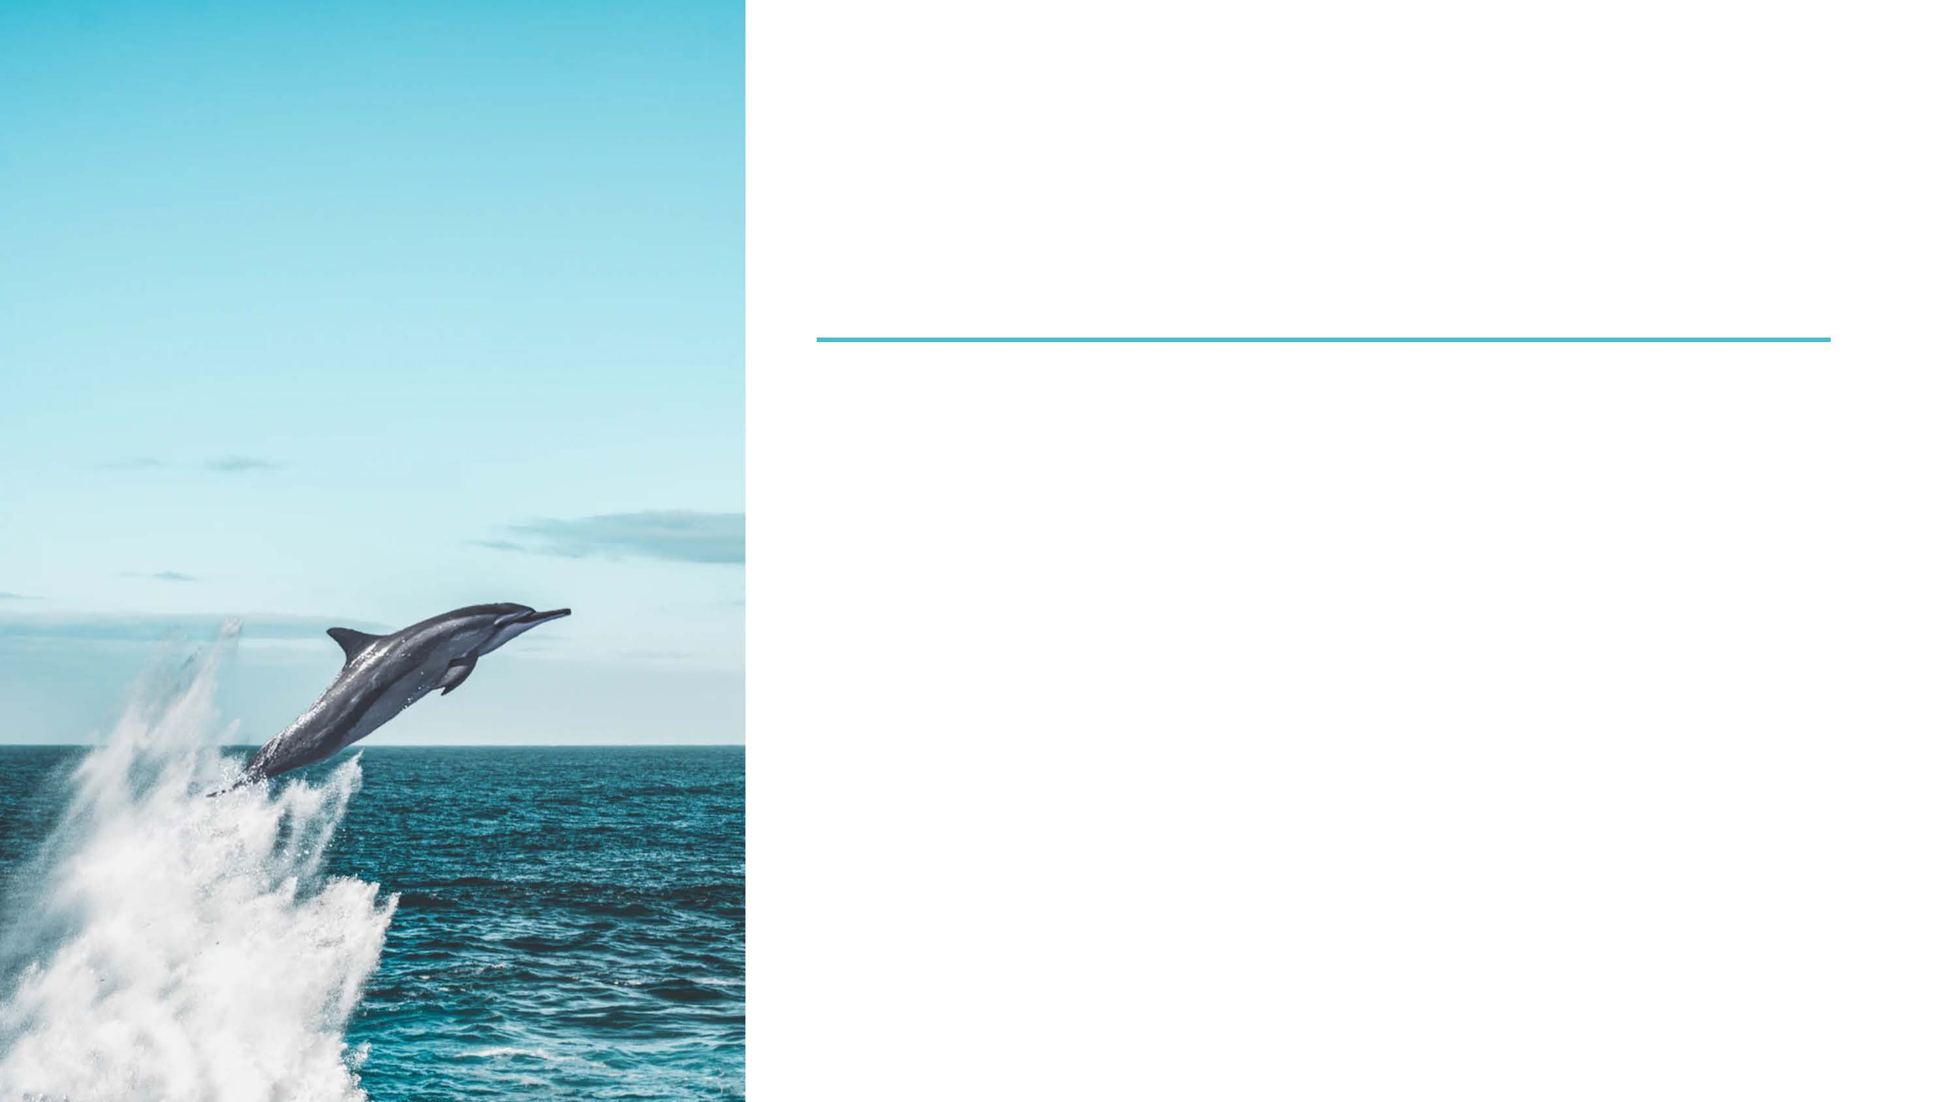

3 decades of research:

~~charisma~~

~~influence~~

~~power~~

~~extroversion~~

~~Innovative genius~~

**Positive relational energy** → How you make others **feel**

Even in the worst of times/cases,

You can breathe life back into organizations

Greatest Predictor of Success for a Leader

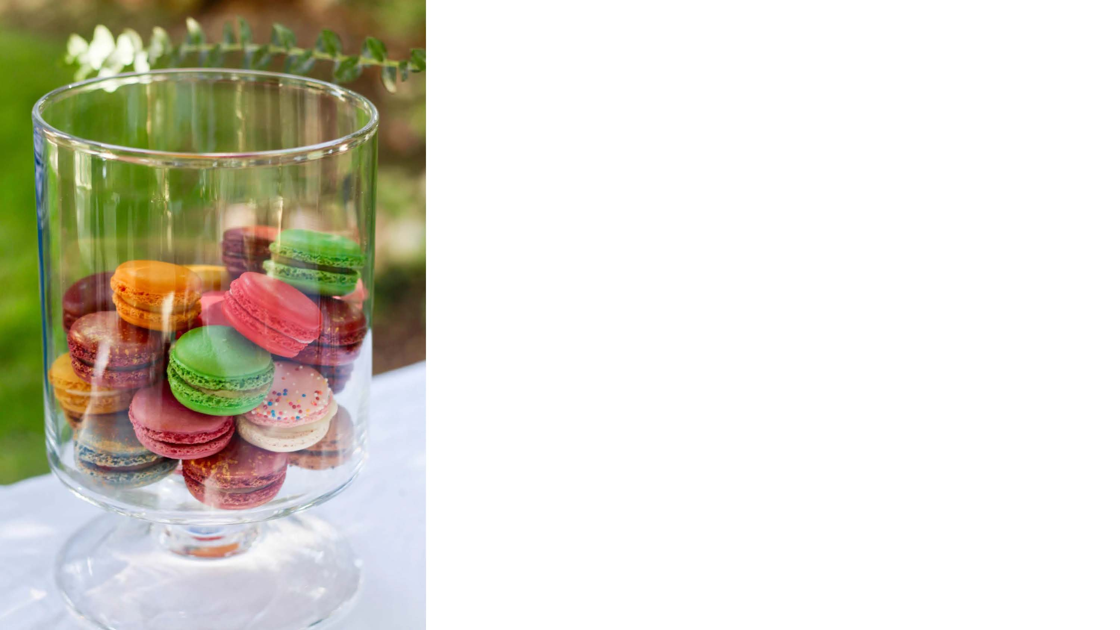

Positively Energizing Leaders

Are far higher performers than others

Other people tend to flourish in their presence

Highly performing organizations have many more PELs than normal organizations



Positively Energizing Leaders

Better workplace climate / teamwork/ cohesion

High Engagement / lower burnout

Loyalty / lower turnover

Superior productivity / financial profit / performance

Increased customer satisfaction / shareholder returns

More Innovation

Their employees have more:

job satisfaction, well-being, engagement, performance & family well-being



WHY?



The Heliotropic Effect





**Social Resources:**

strengthens relationships & builds new ones

**Psychological Resources:**

resilience, optimism, identity & goal orientation

**Physical Resources:**

coordination, strength & cardiovascular health

**Intellectual Resources:**

problem-solving, learning, attention

Positive Emotions



Social Connection

“The Need to Belong”

Similar brain regions as pain

**Poor Social Connection**

>Smoking, obesity & high blood pressure

**Increases** anger, anxiety, depression, jealousy, sadness, aggression

**Decreases**, impulse control, cognitive performance, sleep, immunity

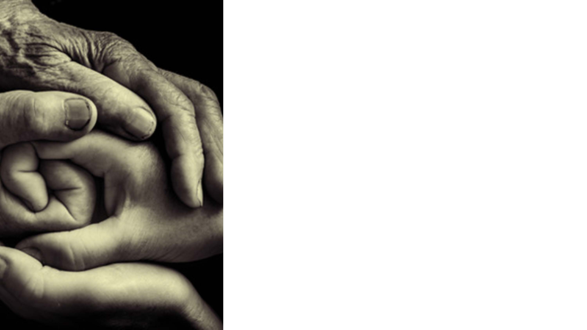

Social Connection

**Strong social connections →**

Boosted immune system

Quicker recovery from disease

50% increased chance of longevity

Lower rates of anxiety/depression

Higher self-esteem, more trust, empathy

Boosts well-being, releases opioids



Emotion is contagious



People don’t remember what you said, they remember how you made them feel.

Maya Angelou



How?

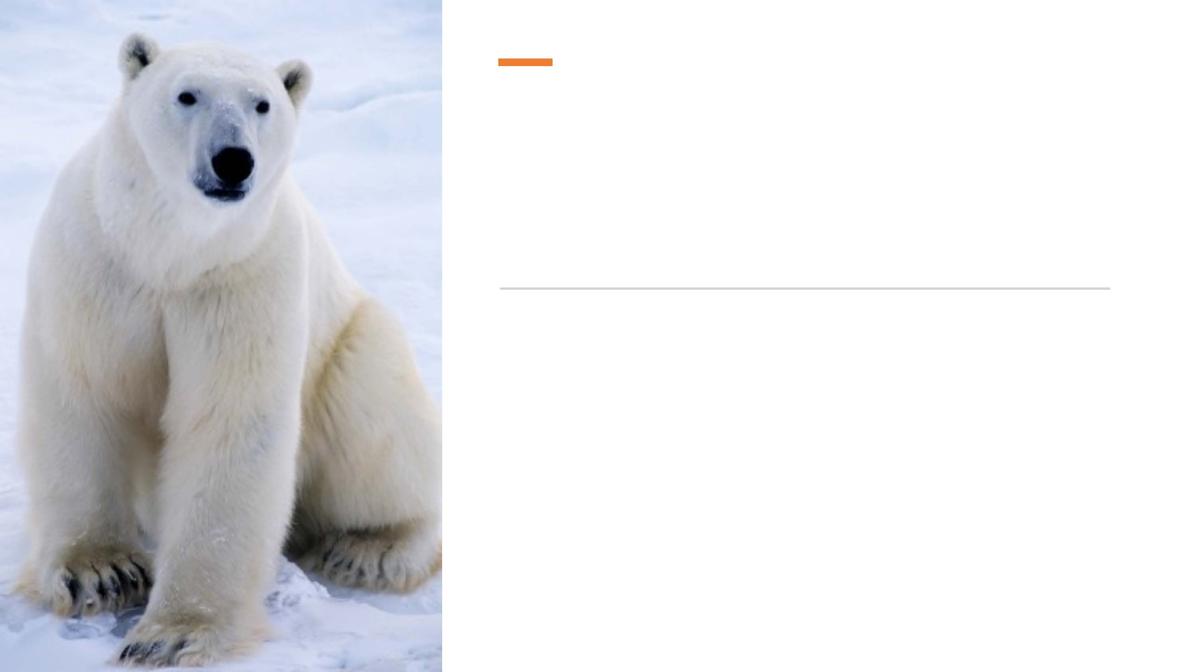

The White Bear phenomenon

A positive target > a negative target

Coronary artery bypass surgery patients study

People remember criticism, but **respond** to praise

Positive Messages Increase Motivation



Emphasize successes

Focus on strengths

Celebrate the positive > correcting the negative

Begin meetings celebrating what is going right

Model positive energy

Give other positive energizers the stage

Highlight positive images more than problematic ones

→ Enable the development of positive relationships

Positive Leaders

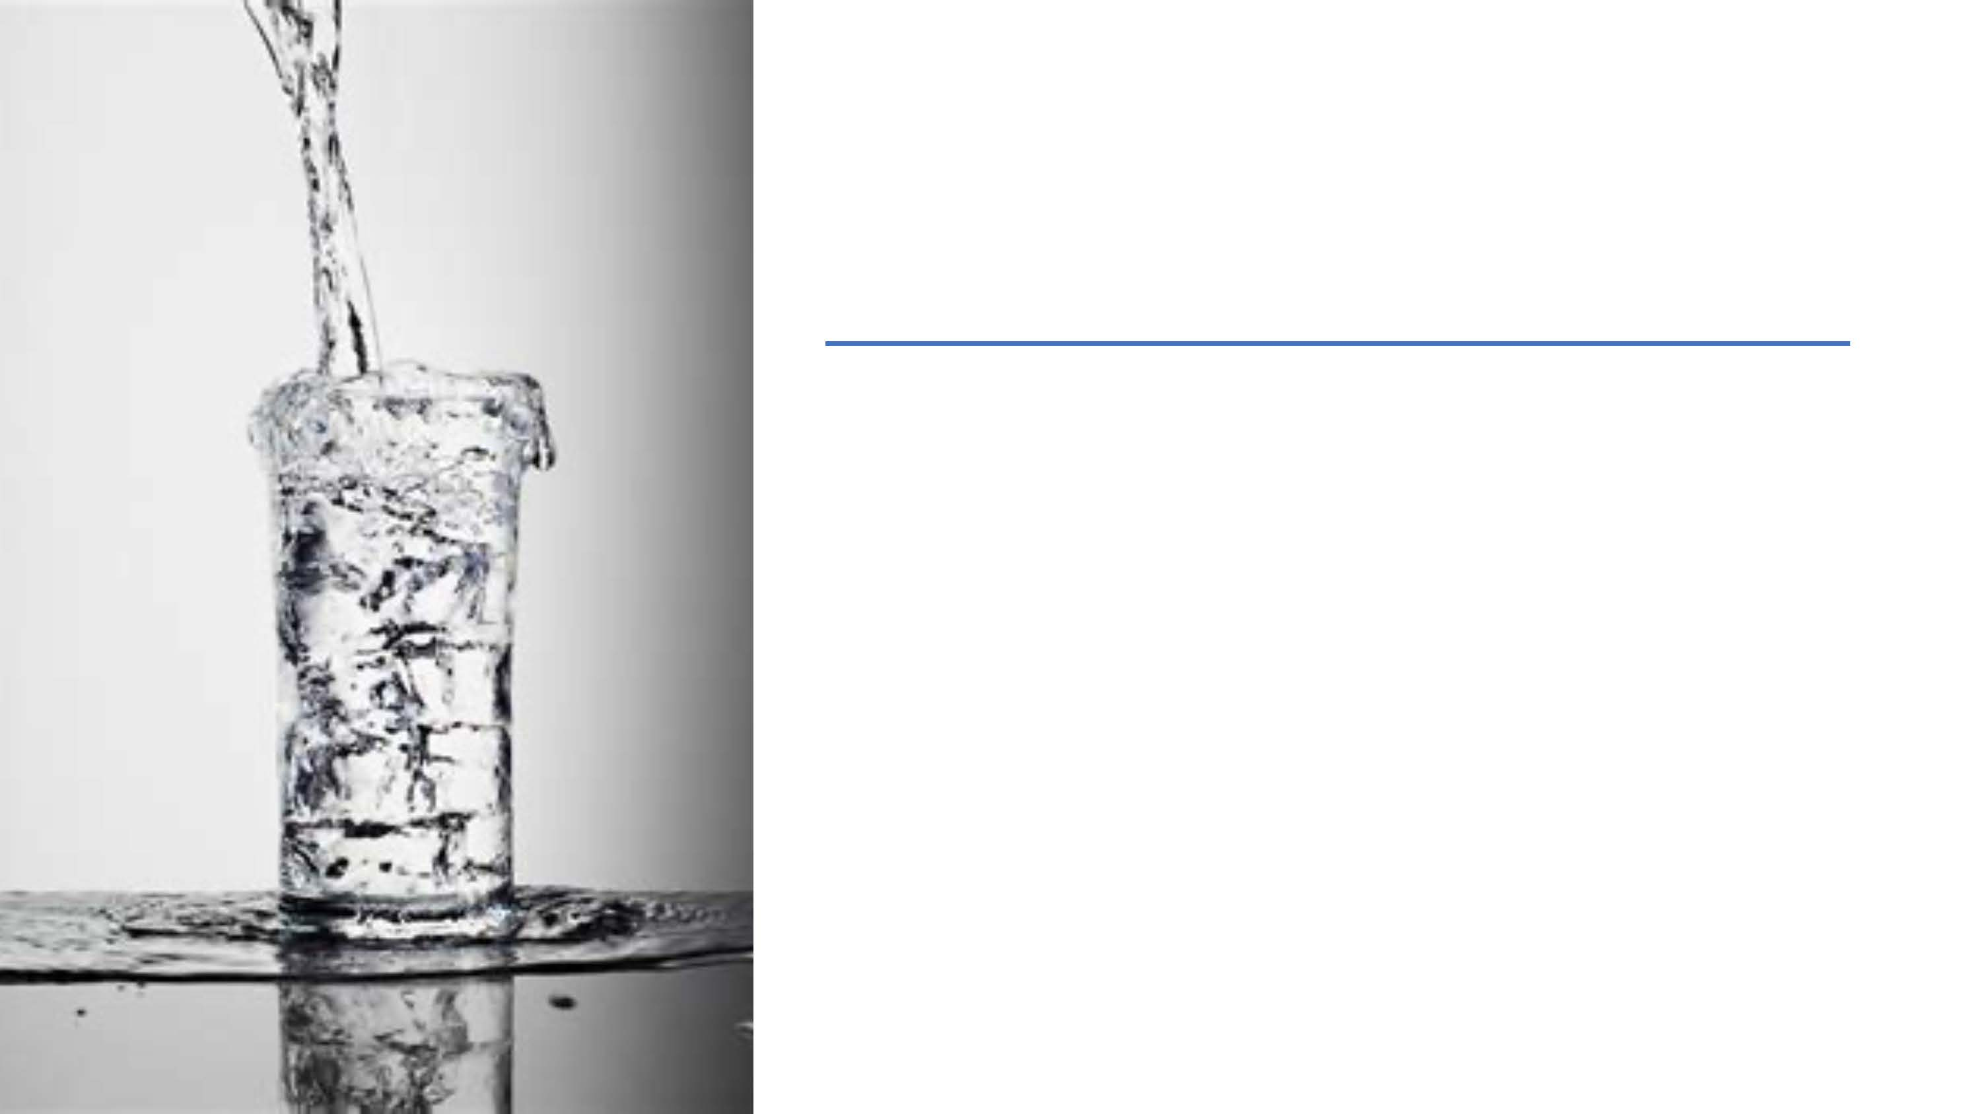

**Compassion, humility, kindness, trust, integrity, honesty, generosity, gratitude, recognition**

Fill **their own cup** so it can overflow

Further enhance their energy **by serving others**

Are not doormats/Have **good boundaries**

Positive Leaders



Caring for, colleagues **as friends**

Providing **support and compassion** when others are struggling

**Inspiring** one another at work

Emphasizing **the meaningfulness** of the work

Avoiding blame and **forgiving** mistakes

Treating one another with **respect, gratitude, trust and integrity**

Positive Workplace Culture



Elevation

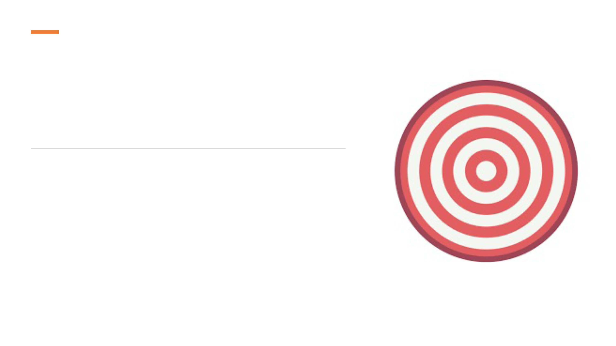

Kindness Spreads

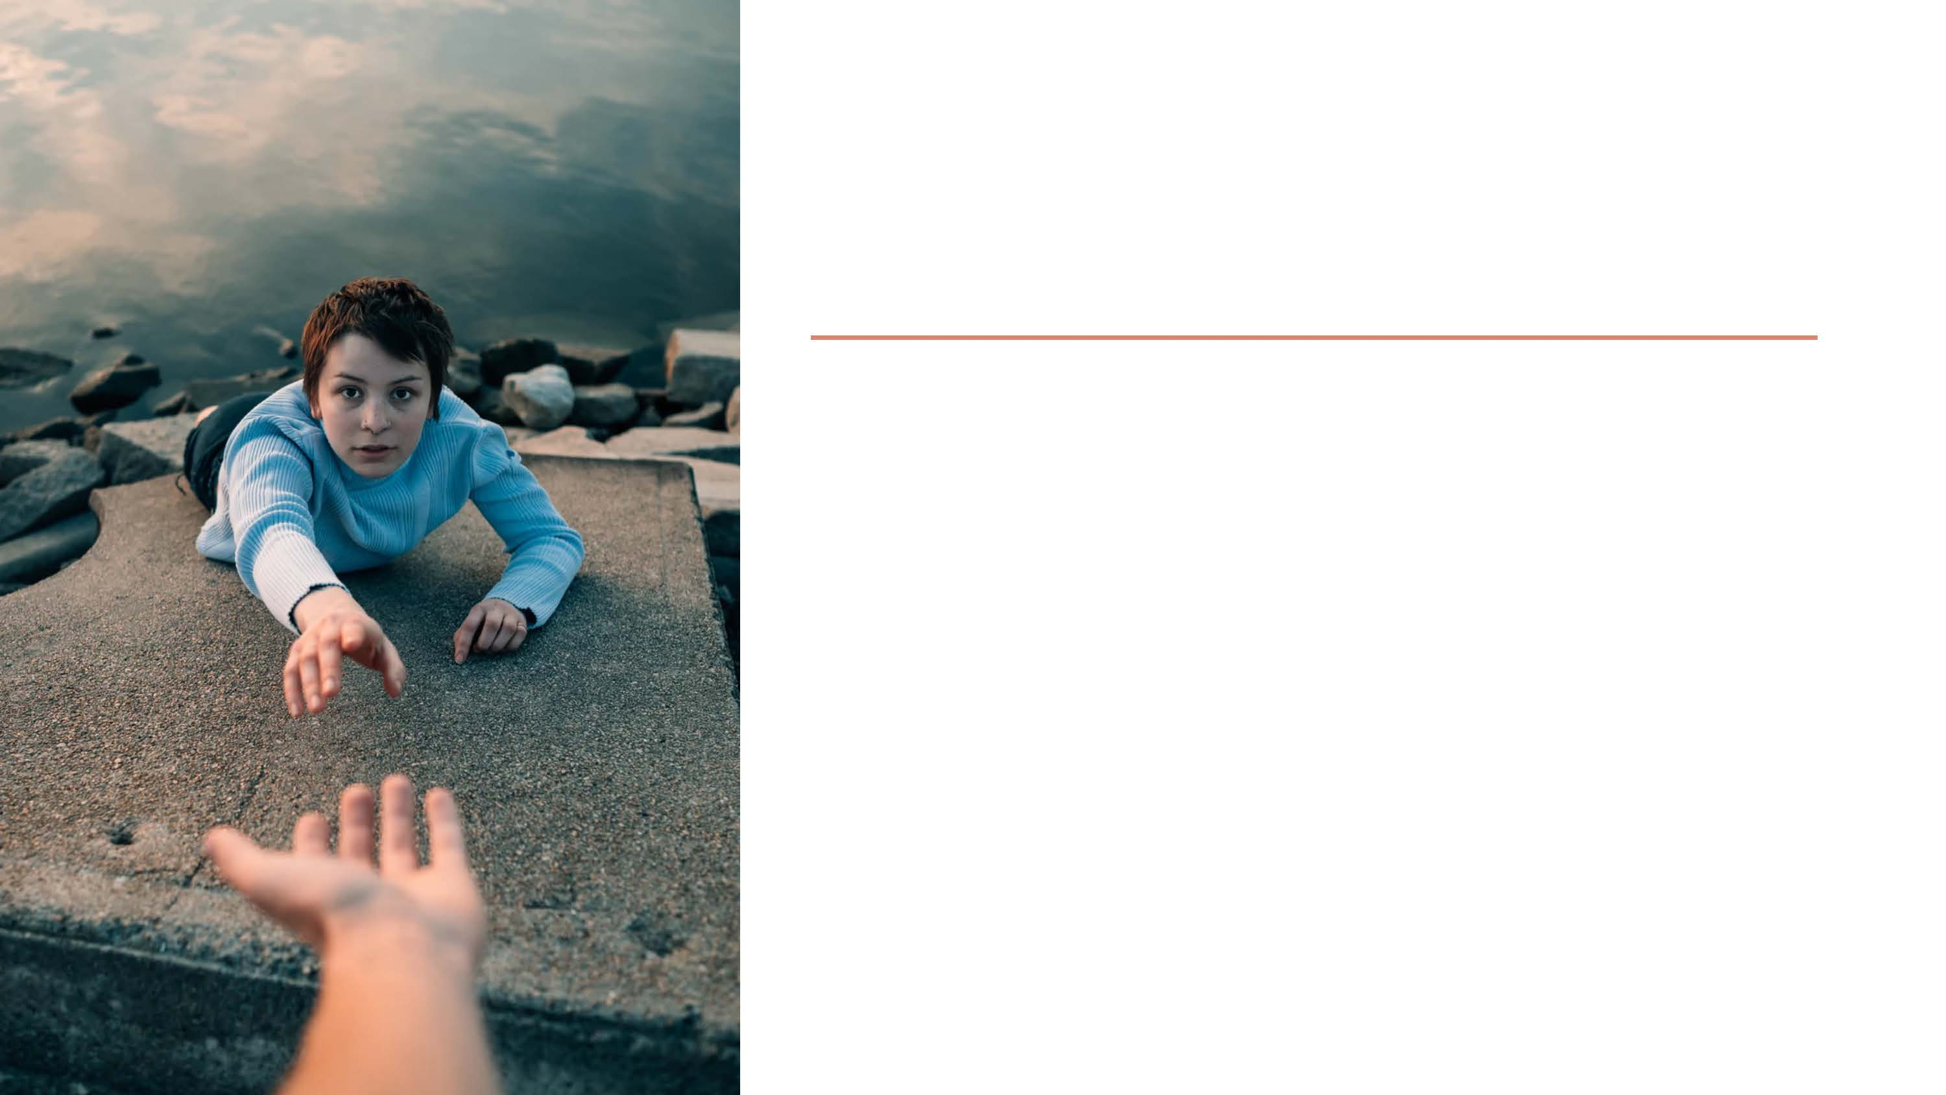

Followers feel elevation

Organizatioal citizenship behavior & commitment increases

Positive Leaders



Have a good relationship with themselves.

Positive Leaders



Positive Emotions Build Resources

**Social:** solidify & build bonds

**Psychological:** resilience, optimism & identity & goal- orientation

**Physical:** coordination, strength & cardiovascular health

**Intellectual:** problem-solving, learning, attention & memory



Self-Care

What are you doing that’s working?



= Listening to Yourself

- Physically

- Emotionally

- Mentally

- Spiritually

Rate Yourself Right now on a Scale from 0 to 5

Self-Awareness



~~What do I need~~ **~~to do~~** ~~right now?~~

What do **I** need right now

- Physically

- Emotionally

- Mentally

- Spiritually

Self-Awareness



Sleep



Diet



Energy Management

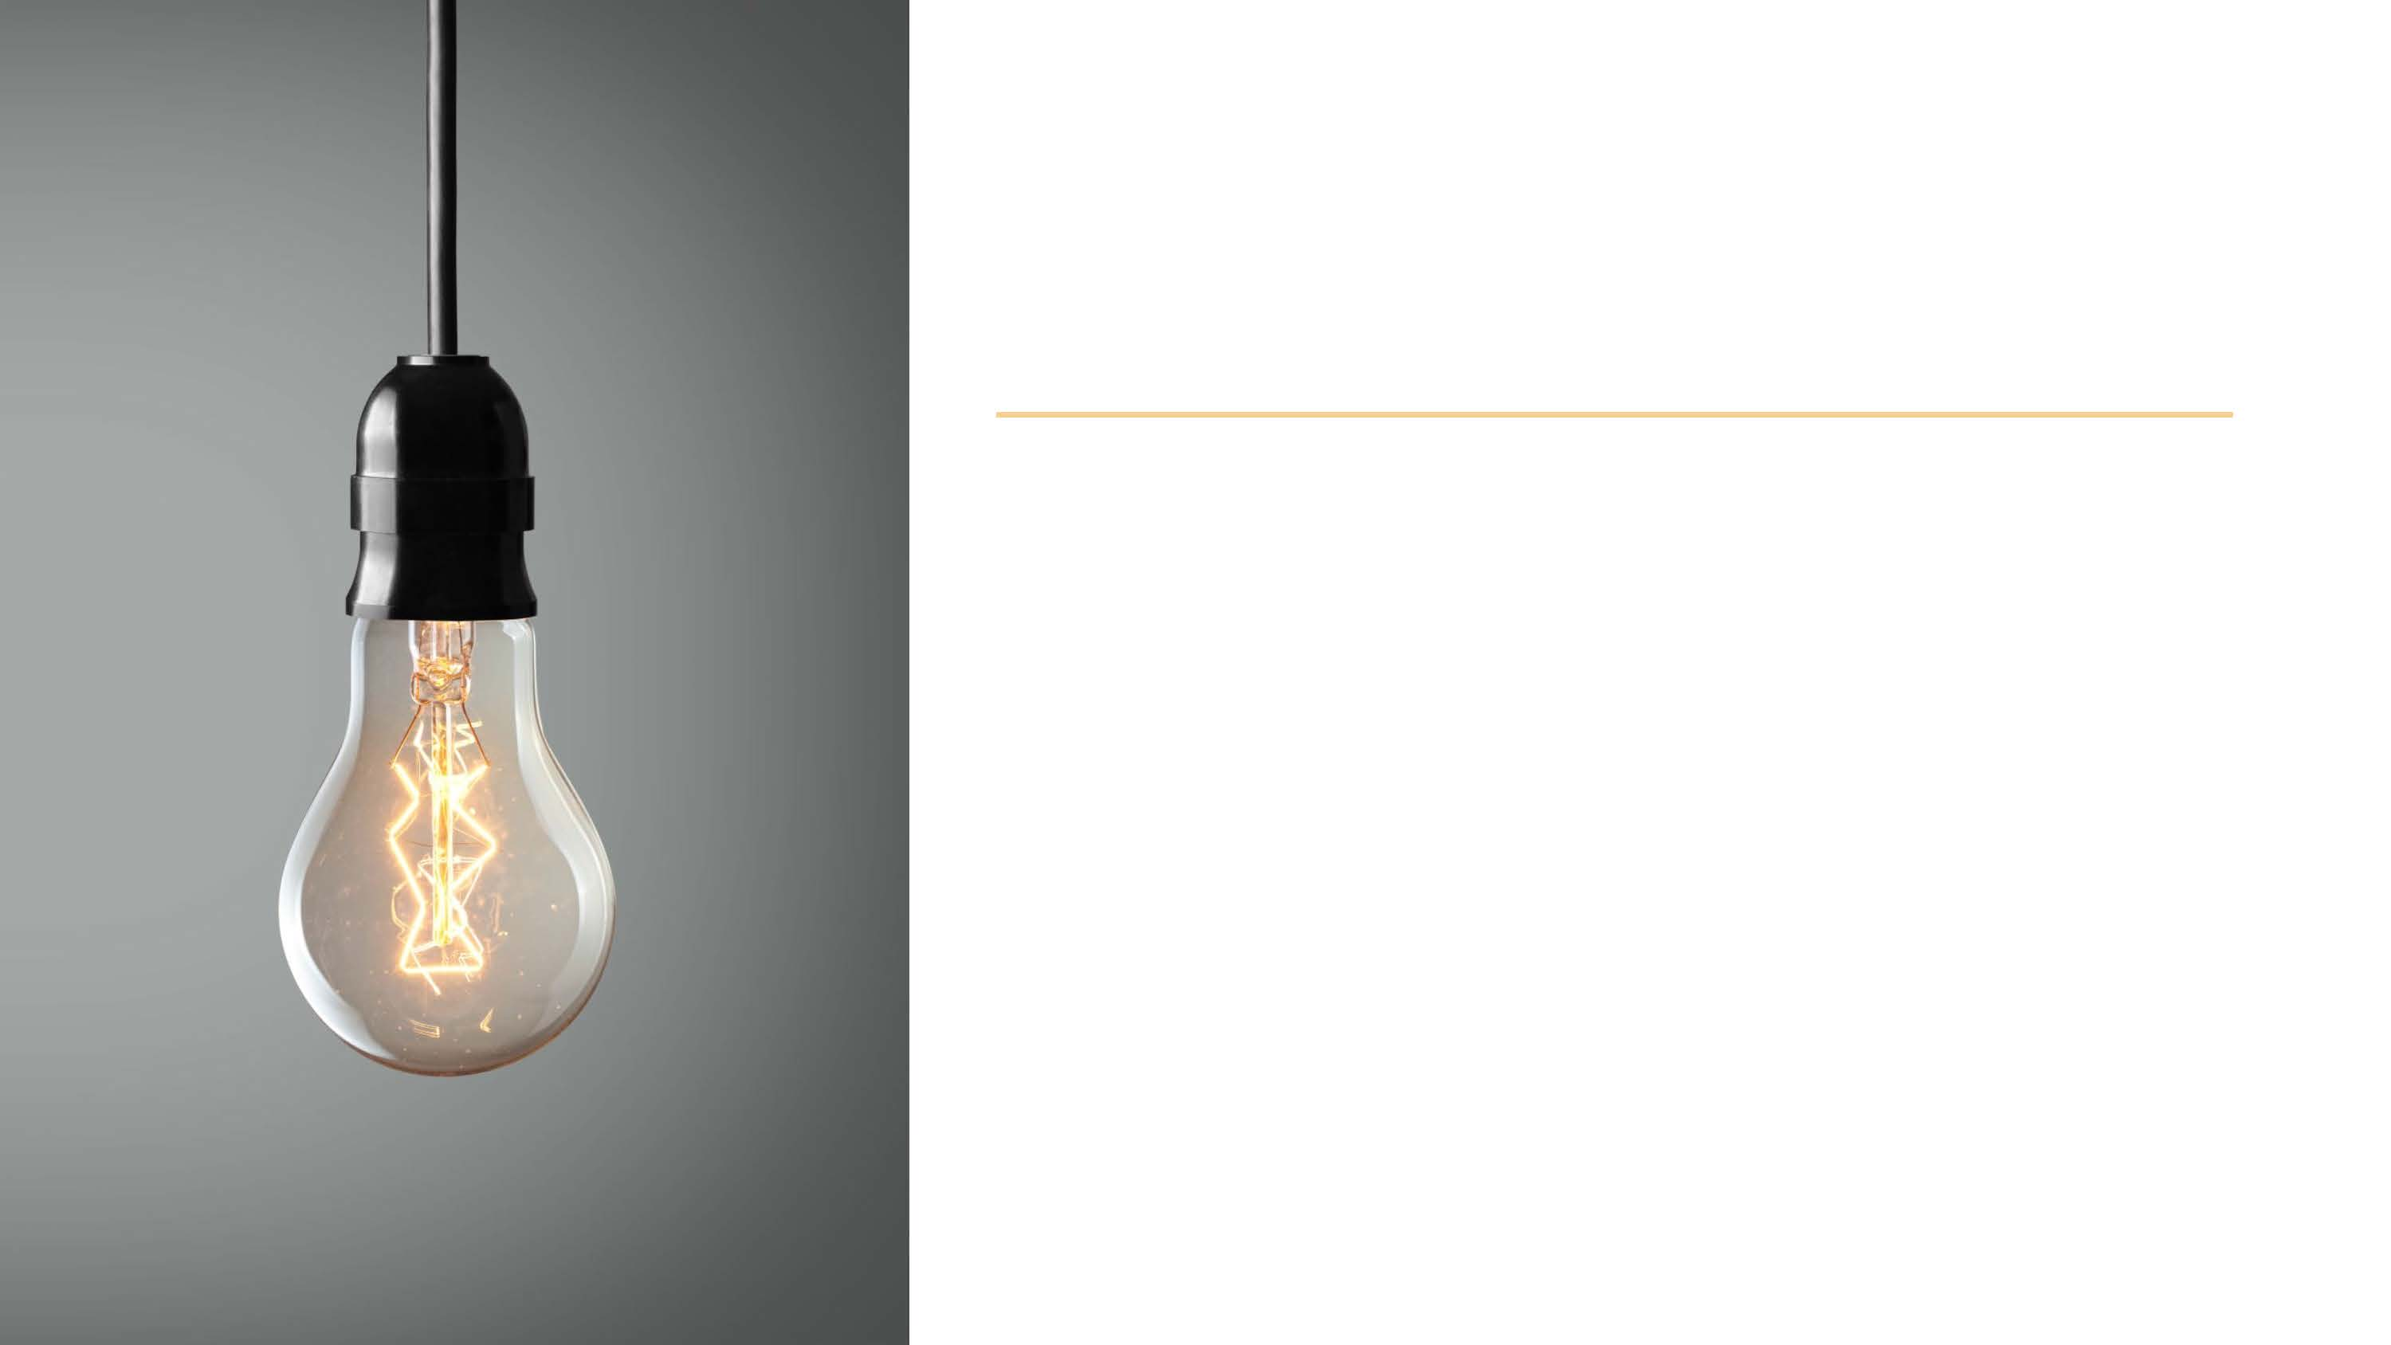

Energy Burners:

• Overcaffeinating

• Overscheduling

• Overcommitting

• Waiting to get things done

• High intensity emotions

• Worrying & catastrophizing

• Stress

Saving Energy



**Lowers**

Anxiety, depression, stress impulsivity

**Boosts**

Mood, well-being, relaxation

Attention, memory

Creativity, innovation

Social connection, helping behavior

Nature



**Lowers** anxiety | depression

**Boosts** mood | well-being | relaxation

**More powerful** than mindfulness | emotional intelligence

**As powerful as** therapy for trauma

Breathe





**Strengthens brain function for:**

self-awareness

emotion regulation

self-control

positive emotion

attention

memory

focus

creativity

Meditation



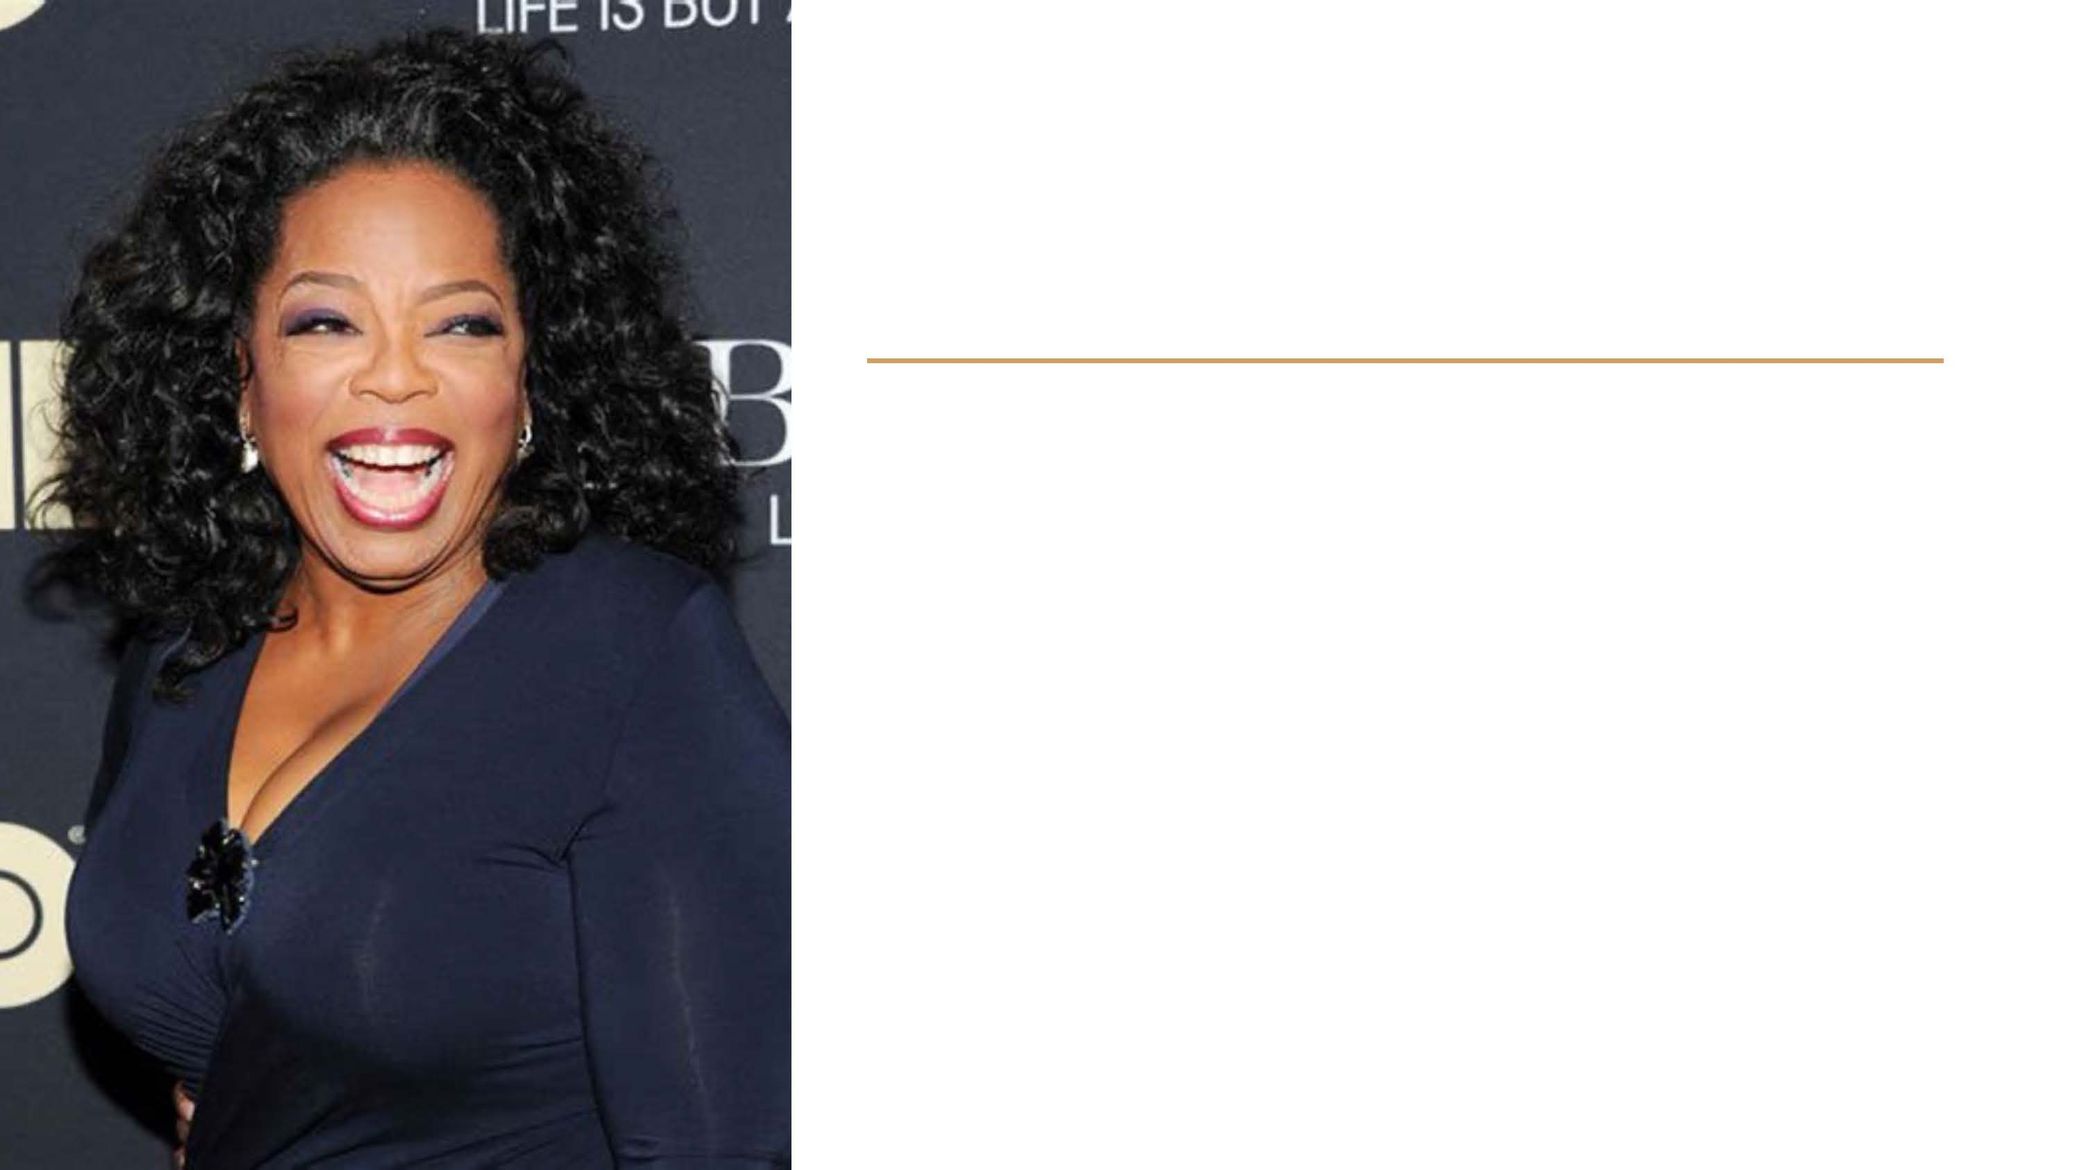

What is it?

Charisma



Empathy

Listening Skills

Eye Contact

Enthusiasm

Self-Confidence

Skillful Speech

→ Absolute Presence

Charisma

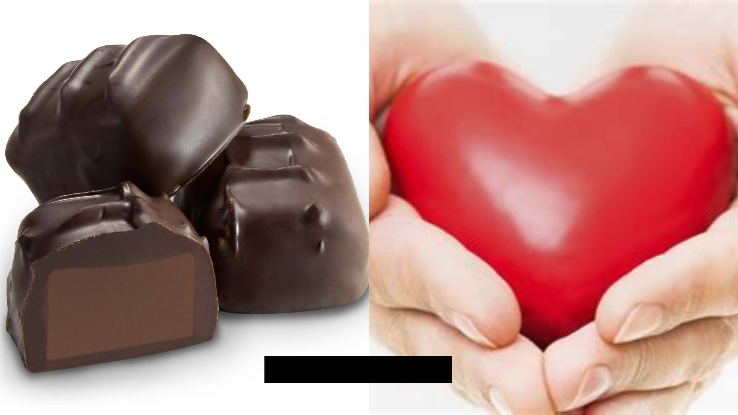

Eudaimonic

Hedonic

**2 Types of Happiness**

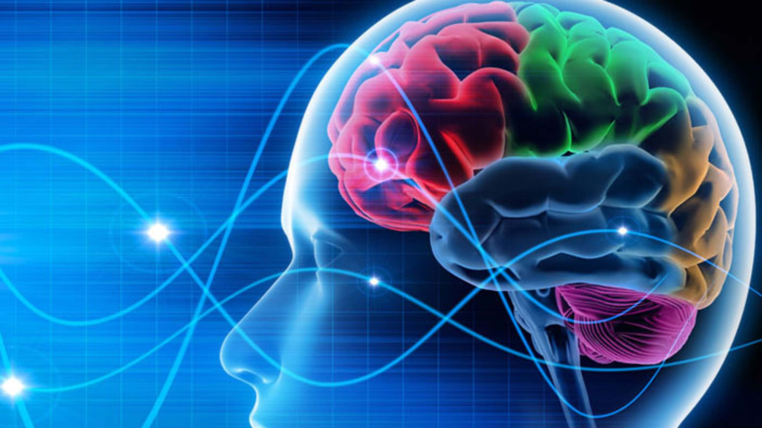

Your Brain on Pleasure



I’ll be happy when…



Desire →

Strive →

Obtain →

Enjoy →

Adapt →

Desire More

(start over)

The Hedonic Treadmill



Negativity Bias



**More Realistic**

**Boosts HAPPINESS:**

Increases Positive Mood, Long-Term

Decreased anxiety and depression

Improves & Helps Maintain Relationships

**Boosts HEALTH**

Improves Sleep Quality & Duration

Strengthens Willpower

Benefits Decision-Making

**Boosts IMPACT**

Increases altruism, morals & ethics

Recipients become more ethical & grateful

Antidote: Gratitude

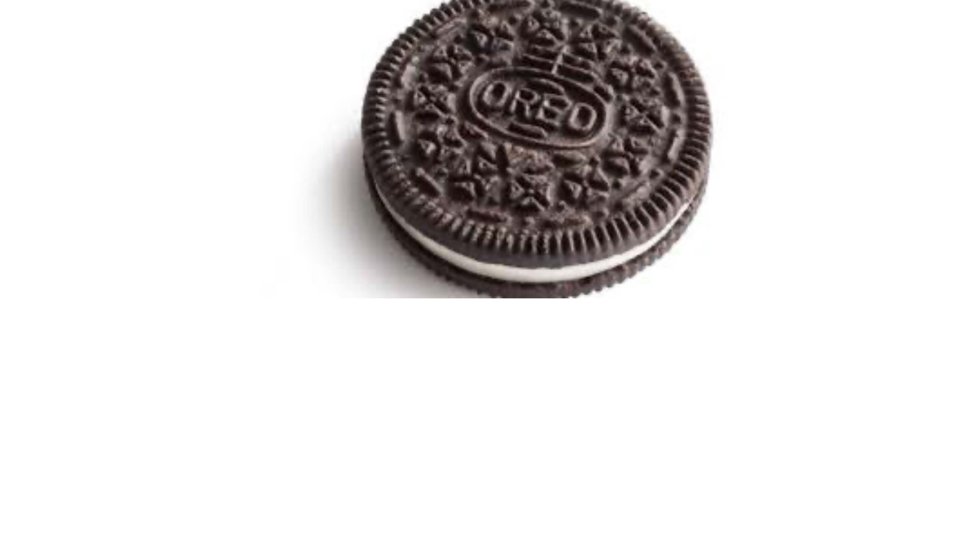

Appreciating Opposites

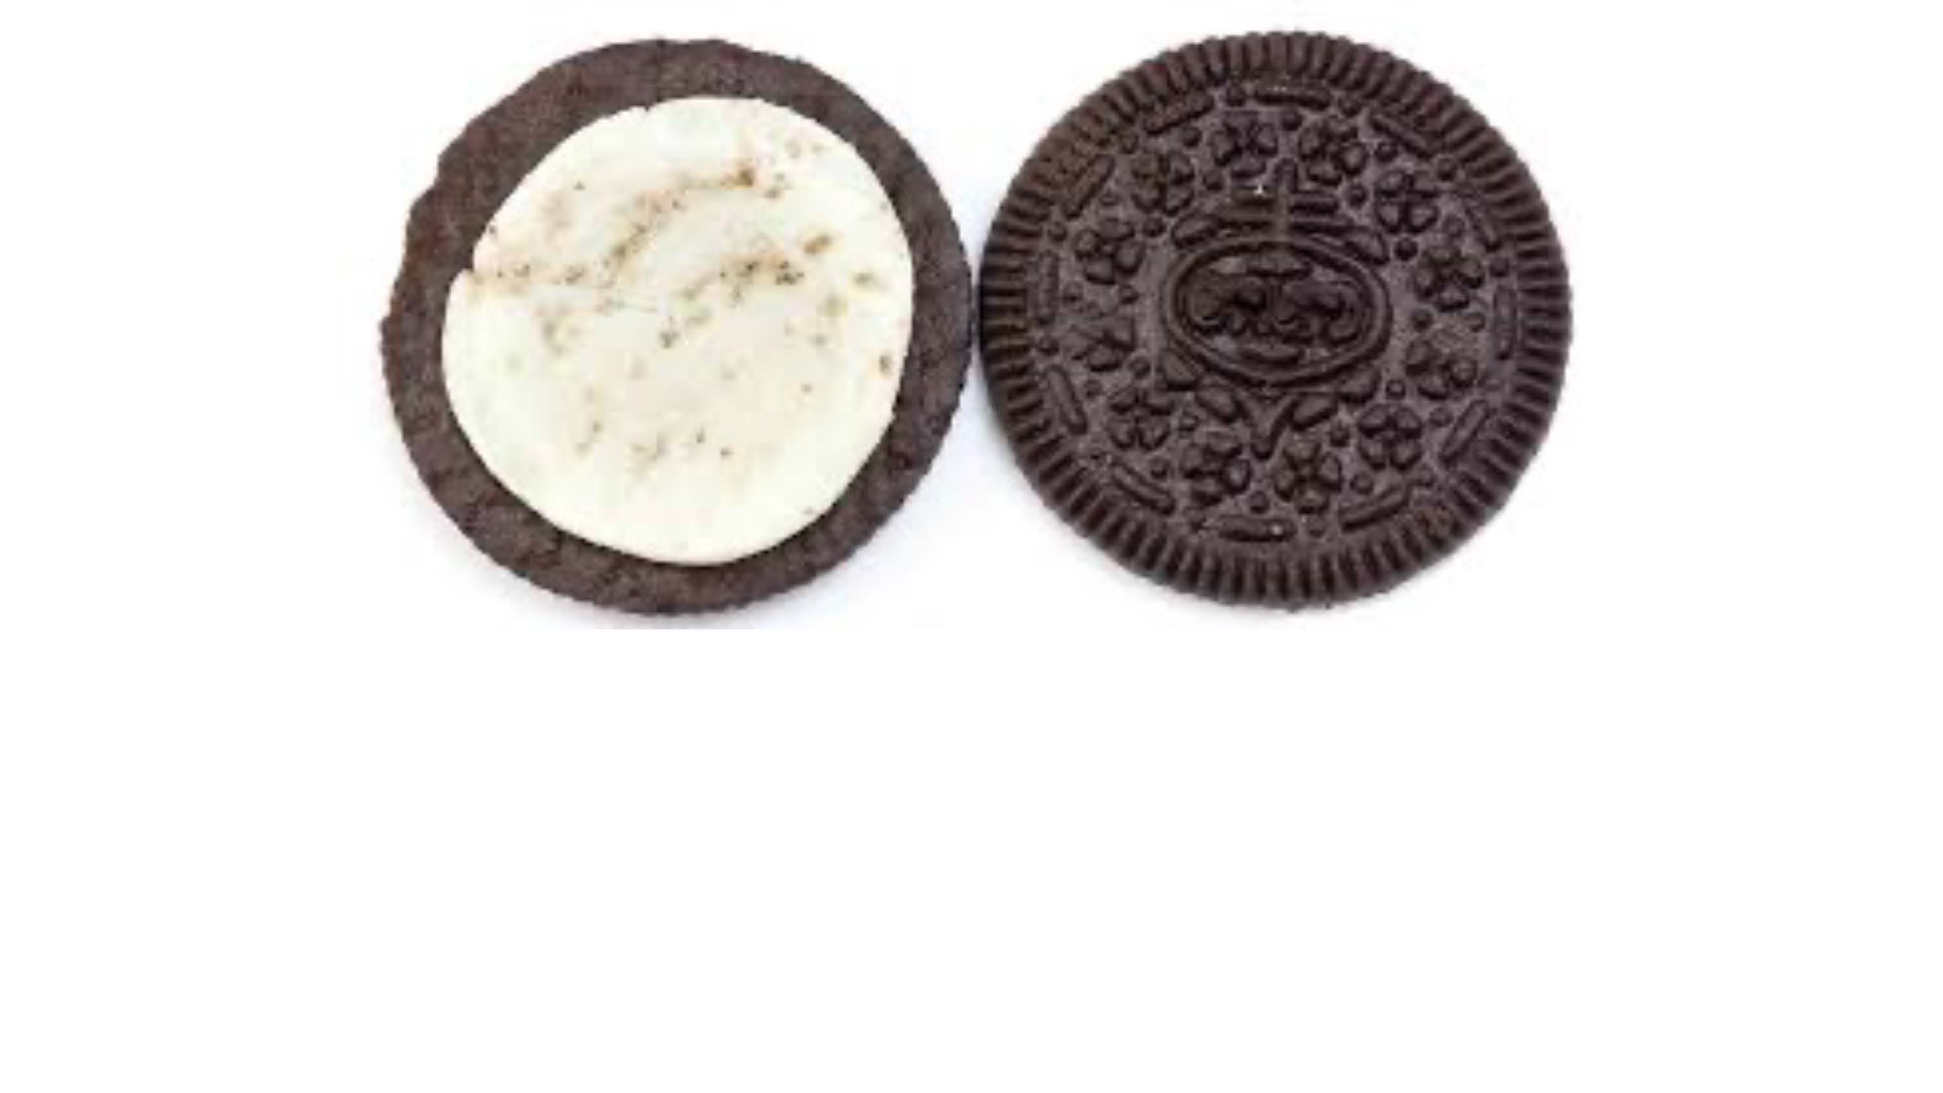

Breakout:

How have life challenges or difficult situations enriched your life?



Finiteness

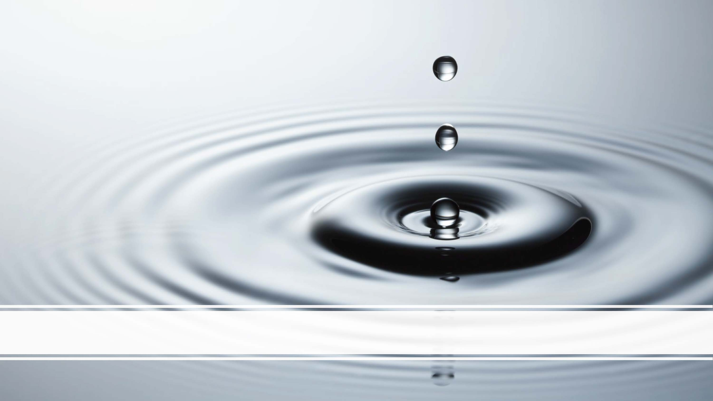

Happiness Spreads (so do all emotions)



**What brings you the greatest sense of fulfillment?**

**If you only had 3 days to live, what would you do?**



**We asked 600 people:**

**What brings you the greatest sense of fulfillment?**

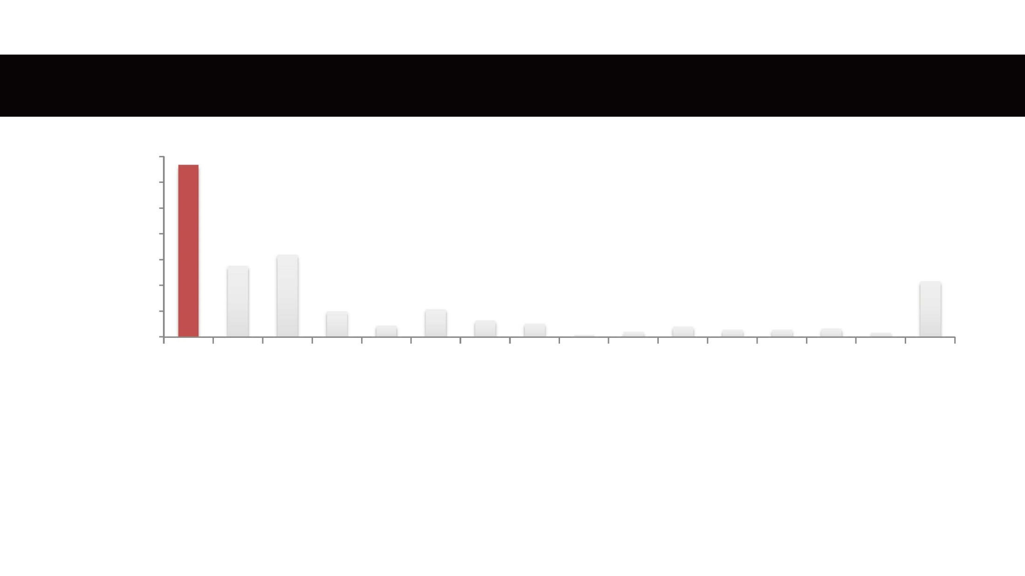

other

Sports

Eating

Cooking

Gardening

Writing

Sleep

Dance

reading

Art

Music

spiritual

sex

physical activity

achieving/performance

connection & helping

35

30

25

20

15

10

5

0

Sources of Fulfillment



**We asked 500 people:**

**If you only had 3 days to live, what would you do?**

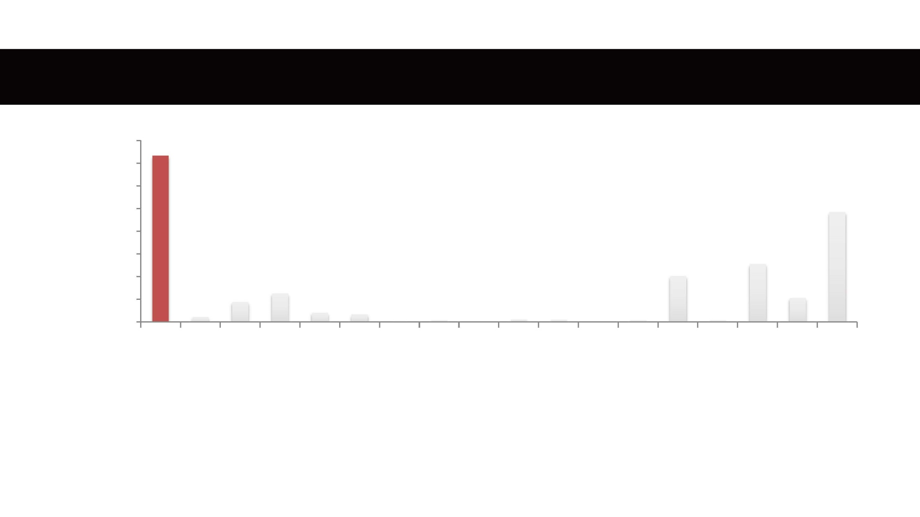

other

Skydive

travel

Sports

Eating

Cooking

Gardening

Writing

Sleep

Dance

reading

Art

Music

spiritual

sex

physical activity

achieving…

social connection &…

800

700

600

500

400

300

200

100

0

3 Days Left to Live



Feeling for someone who is suffering and being moved to help

Compassion

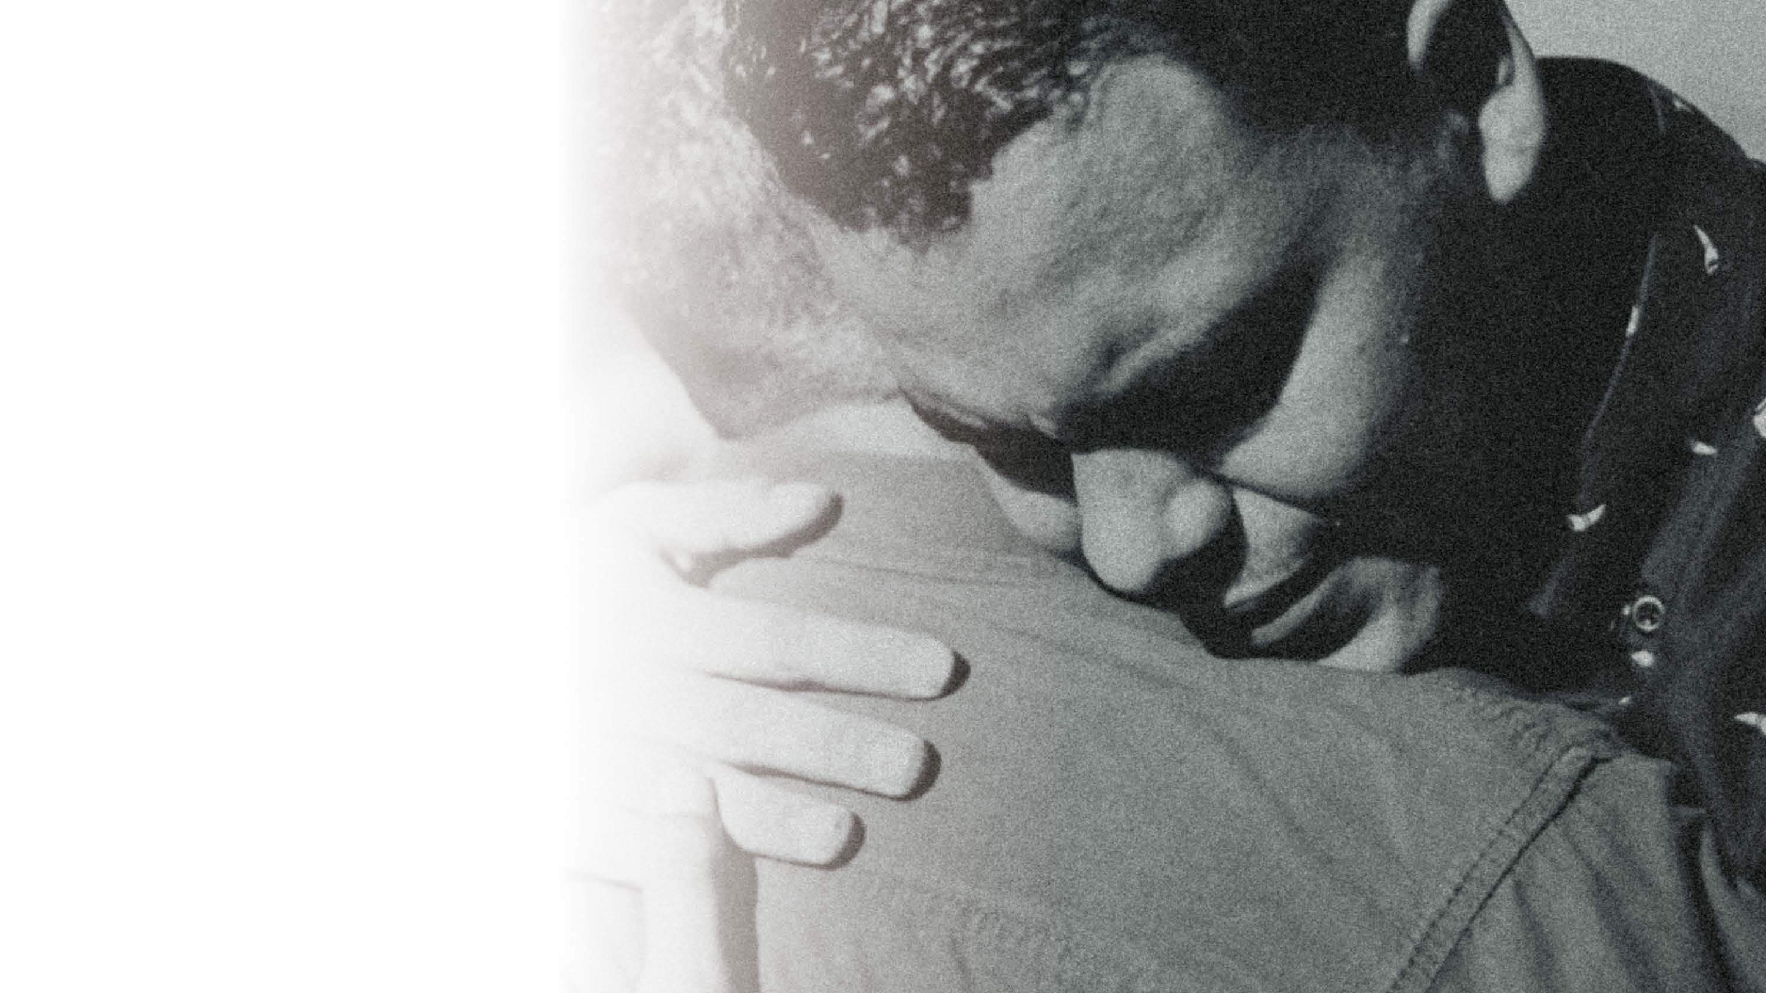

Seeing the human behind the colleague

Fundamental Attribution Error

Boss | heart health (bp, heart disease, heart attack)

**Psychological Safety & Trust**

Everyone feels included, safe, seen, heard, valued

Mistakes : learning opportunities

→ creativity, innovation, problem-solving

Good for you!

Compassion



Survival of the Fittest?

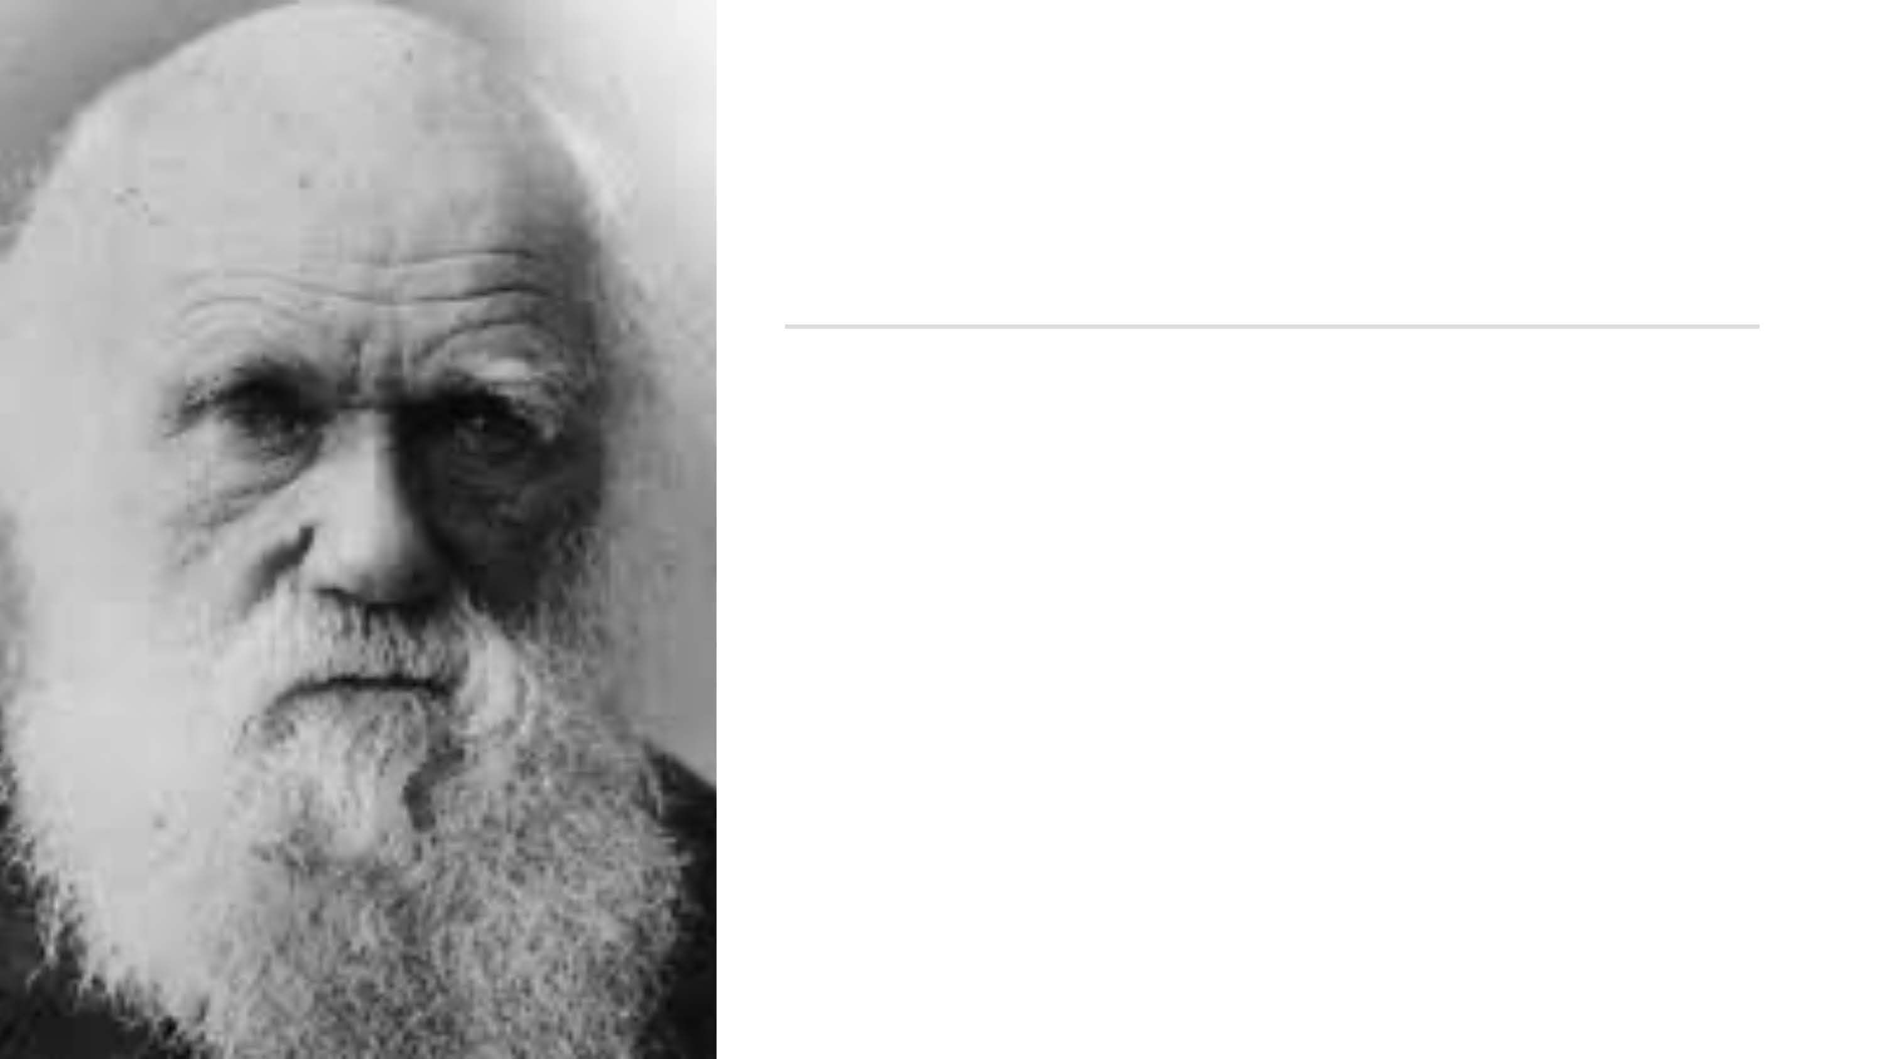

Darwin argued for “the greater strength of the social or maternal instincts than that of any other instinct or motive.”

“Communities which included the greatest number of the most sympathetic members, would flourish best, and rear the greatest number of offspring.”

Survival of the Kindest



Our pleasure centers are as activated when we see money going to charity as when we receive it ourselves.

[[Moll et al., 2006](http://www.pnas.org/content/103/42/15623.full)]

It makes us happier to give to others than to spend on ourselves

[[Dunn, Aknin & Norton, 2008](http://www.sciencemag.org/content/319/5870/1687.abstract)].

This is true even in infants as young as 2!

[[Dunn et al.](http://www.publicaffairs.ubc.ca/2012/06/19/giving-makes-young-children-happy-ubc-study-suggests/) ]

It makes us attractive & it attracts us to others: kindness seen as a “necessity” in mate selection.

[[Li et al, 2002](http://www.mysmu.edu/faculty/normanli/LiBaileyKenrickLinsenmeier2002.pdf)]

Giving makes us happy



Giving boosts health, happiness & longevity more than receiving.

[[Brown et al., 2003](http://pss.sagepub.com/content/14/4/320.short)]

50% increased chance of longevity.

[Holt-Lunstad et al, 2010]

Strengthened immunity

[[Pressman et al, 2005](http://www.ncbi.nlm.nih.gov/pubmed/15898866)]

Anxiety is linked to self-focus, giving focuses you on others.

People with high social connection have better mental health.

[[Tanaka et al, 2007](http://www.ncbi.nlm.nih.gov/pubmed/18027582); [Baumeister & Leary, 1995](http://persweb.wabash.edu/facstaff/hortonr/articles%20for%20class/baumeister%20and%20leary.pdf)]

Giving Improves Health

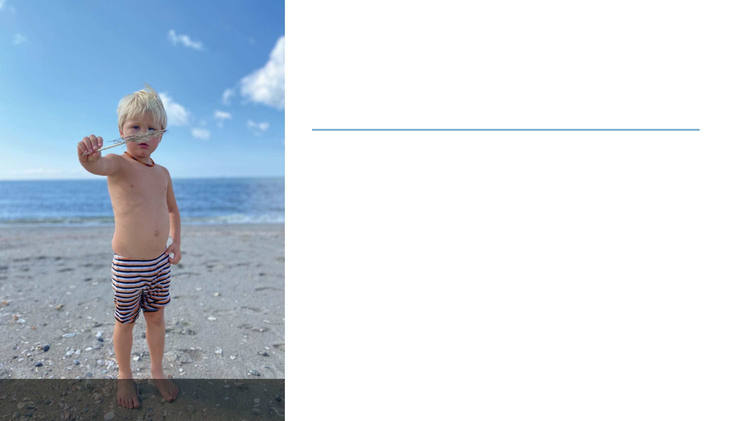

[Tomasello, Max Planck Institute]

• Innate In children

• And adults

• The Norm of Self-Interest

Inborn or Learned?



**Being Kind to Yourself**

Nurturing instead of confronting yourself

Treating yourself as you would a friend

**Mindfulness**

Being aware of your thoughts and feelings without over- identifying with them

**Remembering that Everyone Makes Mistakes**

*Errare Humanum Est –* To Err is Human

Self-Compassion



Compassionate Leadership

There are leaders and there are those who lead.

Leaders hold a position of power or influence.

Those who lead inspire us.

Whether individuals or organizations, we follow those who lead not because we have to, but because

we want to. We follow those who lead not for them, but for ourselves.

~ Simon Sinek



Kindness Also Spreads



What is success?



“Success is liking yourself,

liking what you do,

and liking how you do it”

Maya Angelou

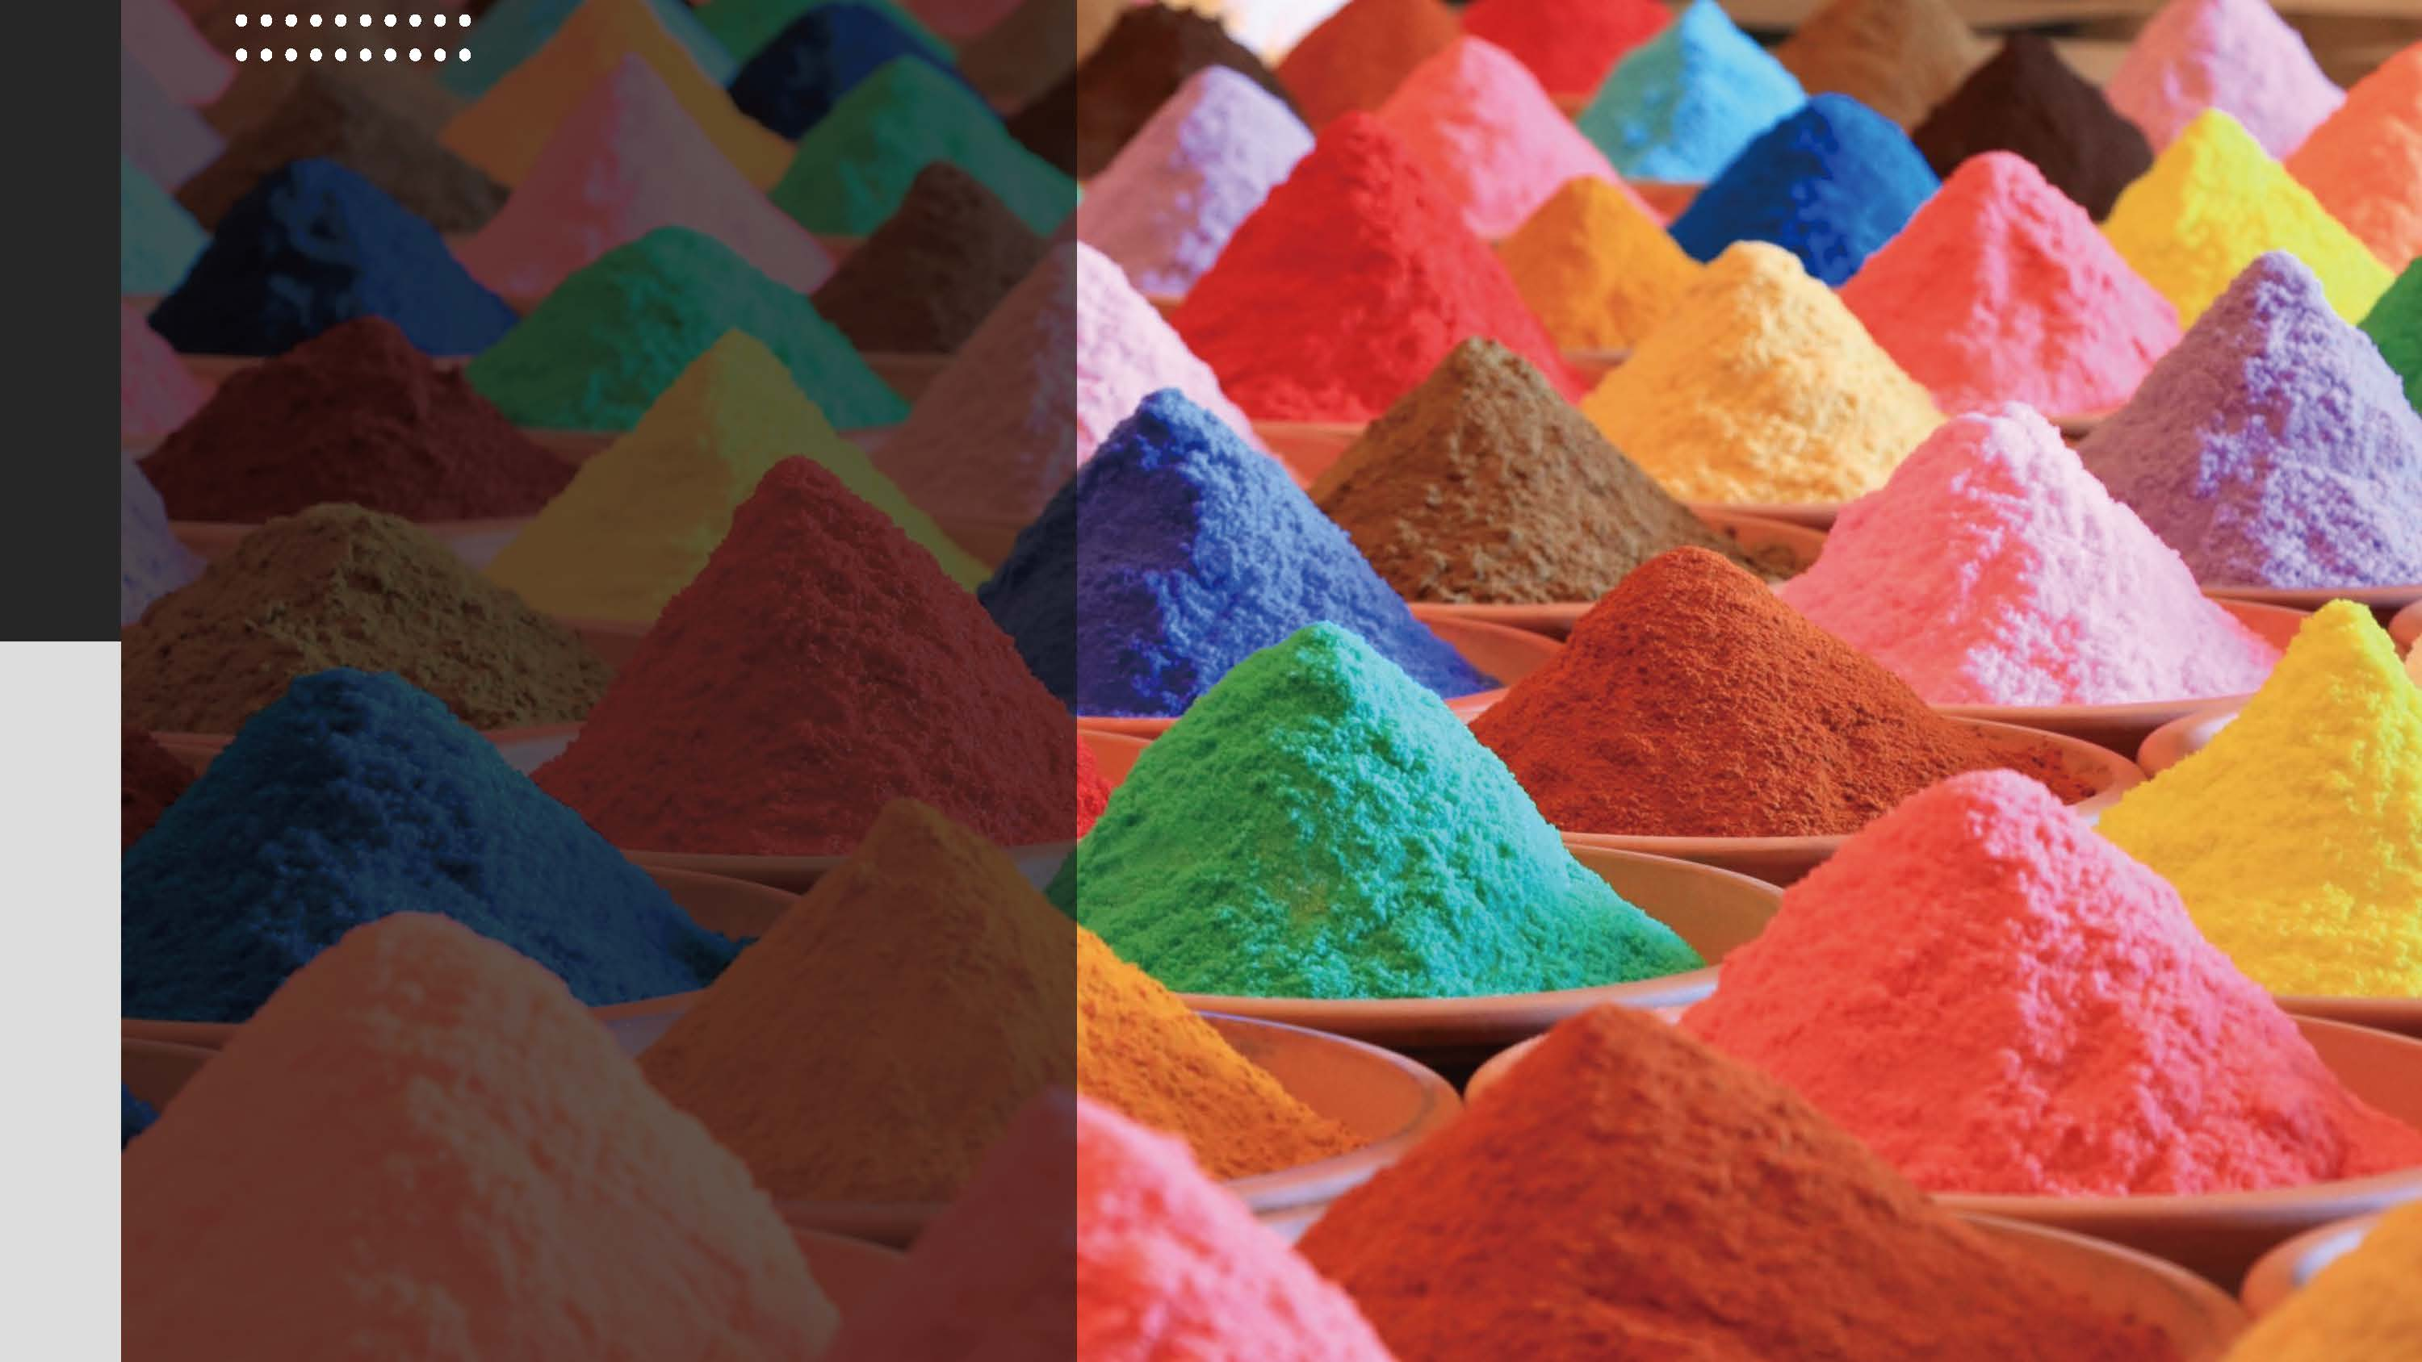

The happiest people who also live the longest and healthiest lives are those who balance compassion for others with compassion for self.

Summary



**Virtuous Actions and Relationships That Create High Performance**

**POSITIVELY ENERGIZING LEADERSHIP**

**KIM CAMERON**

**Copyrighted Material**

**Copyrighted Material**

The Oxford Handbook *of* POSITIVE ORGANIZATIONAL SCHOLARSHIP

**KIM S.**

**CAMERON &**

**GRETCHEN M. SPREITZER**

**EDITED BY**

OXFORD LIBRARY OF PSYCHOLOGY

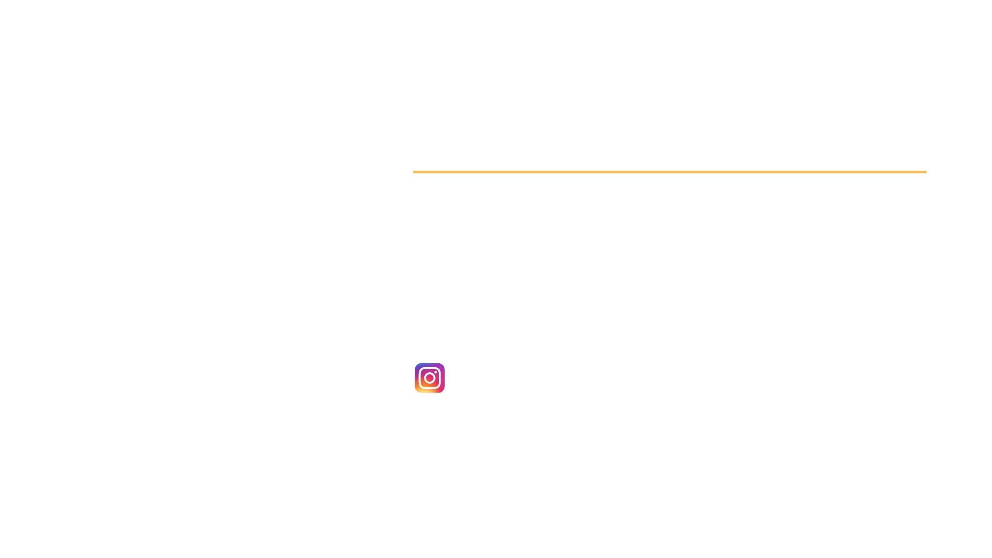

@thehappinesstrack

[emma.seppala@yale.edu](mailto:emma.seppala@yale.edu)

QUESTIONS?

Thank you!